# CS 255 System Design Document Template

## UML Diagrams

### UML Use Case Diagram

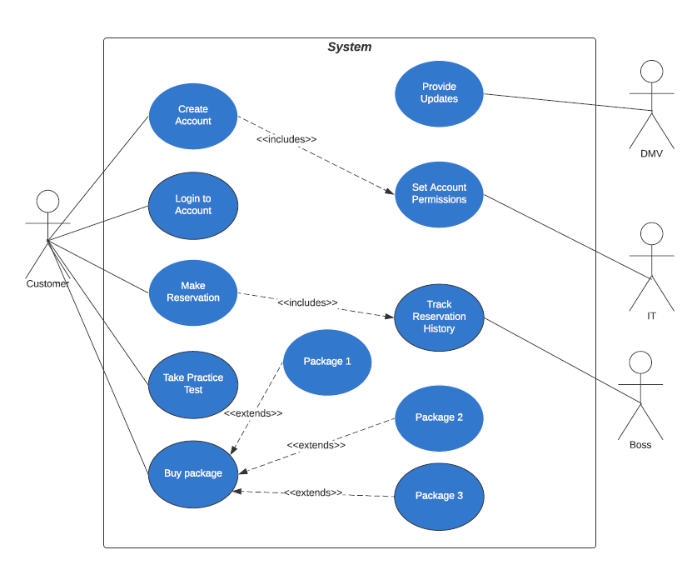

### UML Activity Diagrams

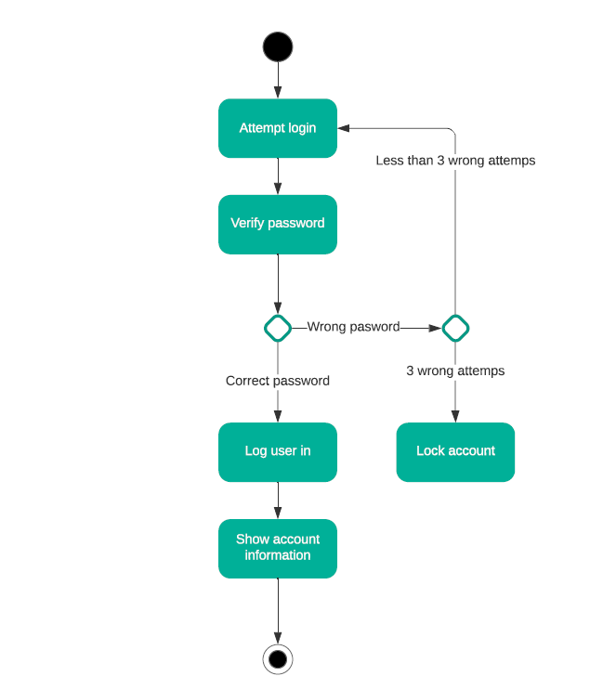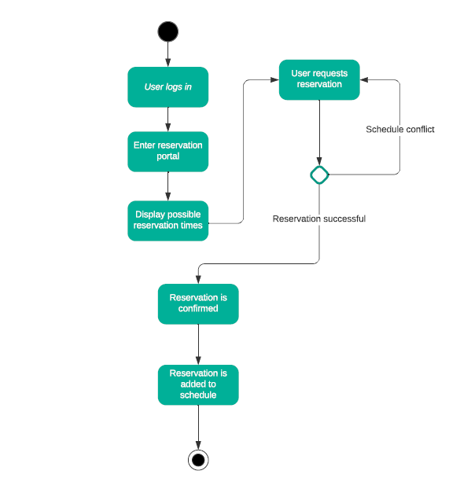

### UML Sequence Diagram

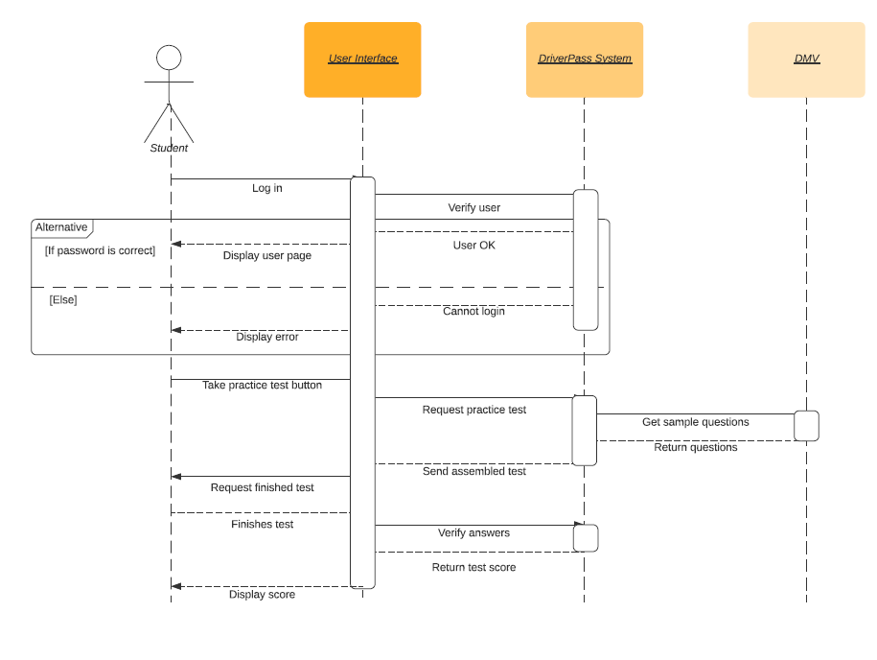

### UML Class Diagram

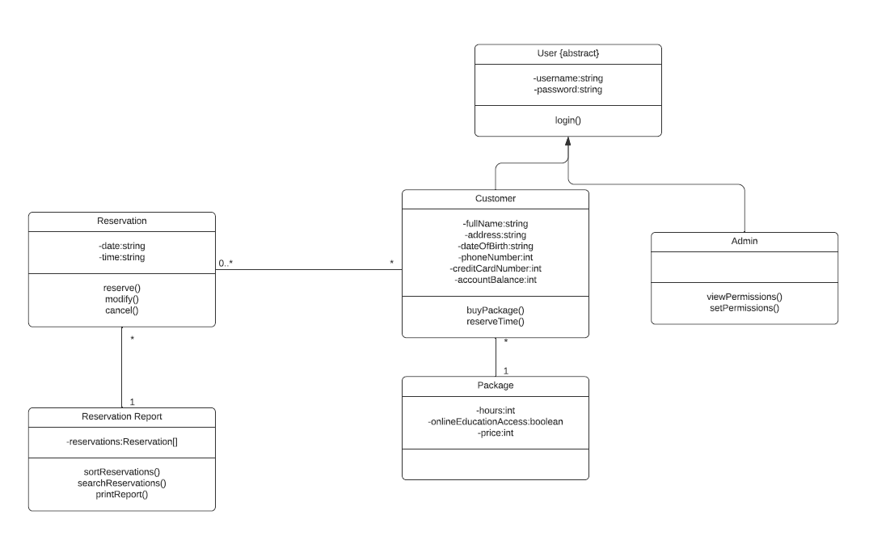

## Technical Requirements

Our system has a few key technical requirements. First and foremost, we will need an online server system that can communicate with mobile and desktop devices. To accomplish this, we can use a cloud computing service to host our server. This way, we do not have to custom build our own server infrastructure for customers to use. The cloud service we use must be secure and reliable. Additionally, we will need developers to write the software we want to run on our servers.

We will need to create an internet browser-accessible user interface that allows users to use the DriverPass system. This will require a development team with experience in user interface design. They will have to know HTML, CSS, and the Javascript programming language.